East Asian Empires Quiz

- The terms Bushido, samurai, and daimyo are most closely associated with which group in Japanese history?
  - Emperors
  - Warriors
  - Peasants
  - Merchants

Base your answer to the following question on the map below and on your knowledge of social studies
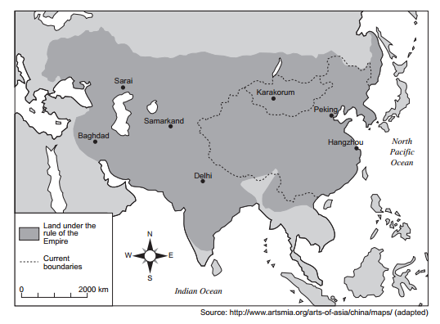
- Which empire is the focus of this map?
  - Mongol
  - Songhai
  - Roman
  - Persian

- Which achievements are most closely associated with the Tang and Song dynasties of China?
  - Wheel and stirrup
  - Chinampas and calendar
  - Gunpowder and moveable wooden type
  - Mosaics and domes

- Which statement about the Tang dynasty is a fact rather than an opinion?
  - Technical advances would have been greater if the Tang dynasty had lasted longer.
  - China’s best emperors came from the Tang dynasty.
  - The Tang emperors granted government jobs to scholars who passed examinations.
  - The culture of the Tang dynasty was superior to that of the Han dynasty.

- Which culture is credited with the development of gunpowder, the abacus, and the compass?
  - Chinese
  - Persian
  - Indian
  - Japanese

- Korea has frequently served as a cultural bridge between
  - Cambodia and Vietnam
  - Russia and India
  - Thailand and Indonesia
  - China and Japan

- Which two belief systems teach that there are spirits in nature?
  - Shinto and animism
  - Hinduism and Confucianism
  - Judaism and Christianity
  - Islam and Buddhism

Base your answer to the following question on the map below and on your knowledge of social studies

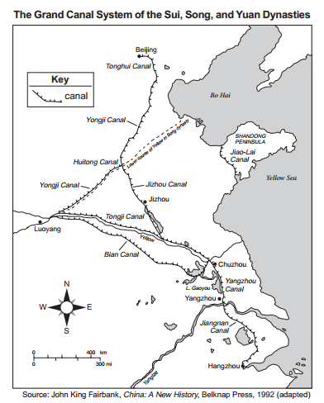
- Which conclusion about the Grand Canal system in China can be drawn from the information shown on this map?
  - Costal ports dominated the canal system.
  - Troops could easily be moved west of Louyang on the canals.
  - Grain could be shipped between Hangzhou and Beijing by the canal.
  - The canal system prevented invaders from conquering the dynasties.

- Which geographic factor directly influenced the early interactions between China and Korea?
  - location
  - monsoons
  - arid climate
  - tropical savannas

Base your answer to the following question on the quote below and on your knowledge of social studies

…As early as the struggle for the steppe he had spread the claim that Heaven had destined him as a ruler; members of Mongol trading caravans spread stories intended to cause panic among the local populace; forged letters were fed to Sultan Muhammad which strengthened his mistrust of his Turkic units; freedom of religion was proclaimed; those who offered no resistance were promised that life and poverty would be spared; terrible destruction was threatened in the event of resistance; bloody examples were designed to spread fear and reduce the populace’s will to resist…
--Paul Ratchnevsky, Genghis Khan: His Life and Legacy, Blackwell Publishing

- According to this passage, which Mongol practice contributed greatly to their success?
  - nomadic lifestyle
  - superior horsemanship
  - psychological warfare
  - religious conversion

East Asian Empires Quiz Answer Key

- The terms Bushido, samurai, and daimyo are most closely associated with which group in Japanese history?
  - Emperors
  - Warriors
  - Peasants
  - Merchants

Base your answer to the following question on the map below and on your knowledge of social studies
- Which empire is the focus of this map?
  - Mongol
  - Songhai
  - Roman
  - Persian

- Which achievements are most closely associated with the Tang and Song dynasties of China?
  - Wheel and stirrup
  - Chinampas and calendar
  - Gunpowder and moveable wooden type
  - Mosaics and domes

- Which statement about the Tang dynasty is a fact rather than an opinion?
  - Technical advances would have been greater if the Tang dynasty had lasted longer.
  - China’s best emperors came from the Tang dynasty.
  - The Tang emperors granted government jobs to scholars who passed examinations.
  - The culture of the Tang dynasty was superior to that of the Han dynasty.

- Which culture is credited with the development of gunpowder, the abacus, and the compass?
  - Chinese
  - Persian
  - Indian
  - Japanese

- Korea has frequently served as a cultural bridge between:
  - Cambodia and Vietnam
  - Russia and India
  - Thailand and Indonesia
  - China and Japan

- Which two belief systems teach that there are spirits in nature?
  - Shinto and animism
  - Hinduism and Confucianism
  - Judaism and Christianity
  - Islam and Buddhism

Base your answer to the following question on the map below and on your knowledge of social studies

- Which conclusion about the Grand Canal system in China can be drawn from the information shown on this map?
  - Costal ports dominated the canal system.
  - Troops could easily be moved west of Louyang on the canals.
  - Grain could be shipped between Hangzhou and Beijing by the canal.
  - The canal system prevented invaders from conquering the dynasties.

- Which geographic factor directly influenced the early interactions between China and Korea?
  - location
  - monsoons
  - arid climate
  - tropical savannas

Base your answer to the following question on the quote below and on your knowledge of social studies

…As early as the struggle for the steppe he had spread the claim that Heaven had destined him as a ruler; members of Mongol trading caravans spread stories intended to cause panic among the local populace; forged letters were fed to Sultan Muhammad which strengthened his mistrust of his Turkic units; freedom of religion was proclaimed; those who offered no resistance were promised that life and poverty would be spared; terrible destruction was threatened in the event of resistance; bloody examples were designed to spread fear and reduce the populace’s will to resist…
--Paul Ratchnevsky, Genghis Khan: His Life and Legacy, Blackwell Publishing

- According to this passage, which Mongol practice contributed greatly to their success?
  - nomadic lifestyle
  - superior horsemanship
  - psychological warfare
  - religious conversion

